Sequence Diagram

diagram describes the system scenario of UC310: Insert new reserve the rooms

3.Add Reserve

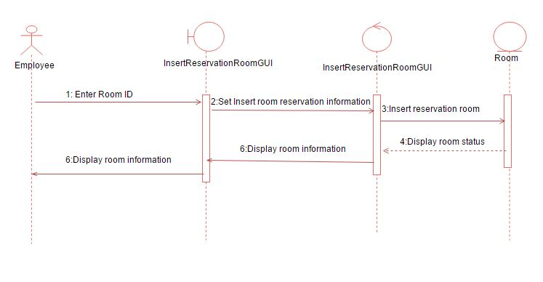

diagram describes the system scenario of UC320 Insert new rental the rooms

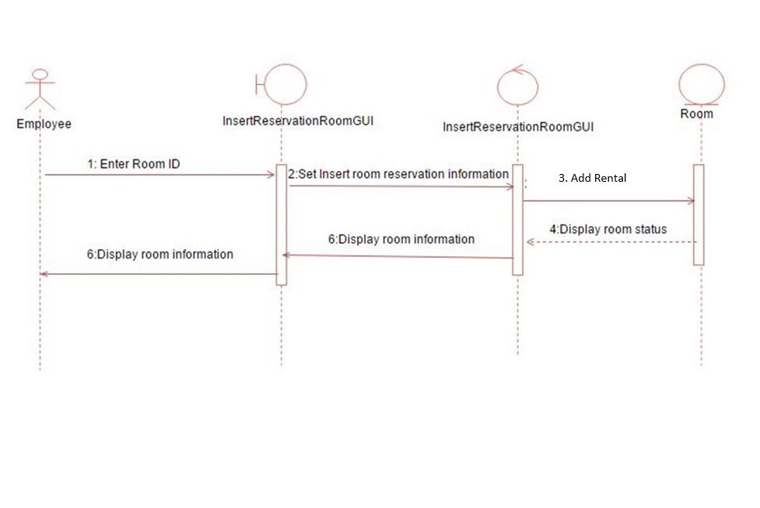

diagram describes the system scenario of UC330 Delete reserve the rooms

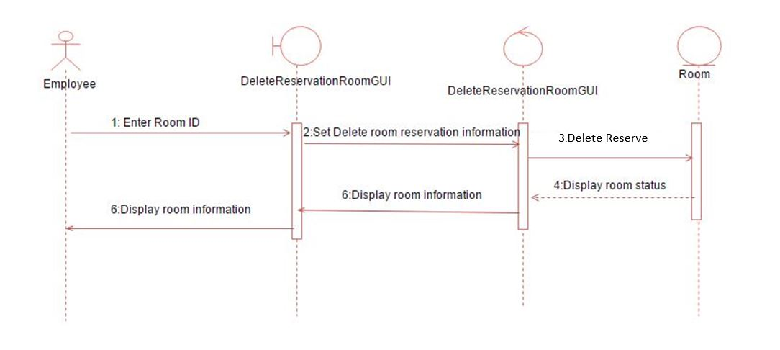

diagram describes the system scenario of UC340 Print document rental agreement

